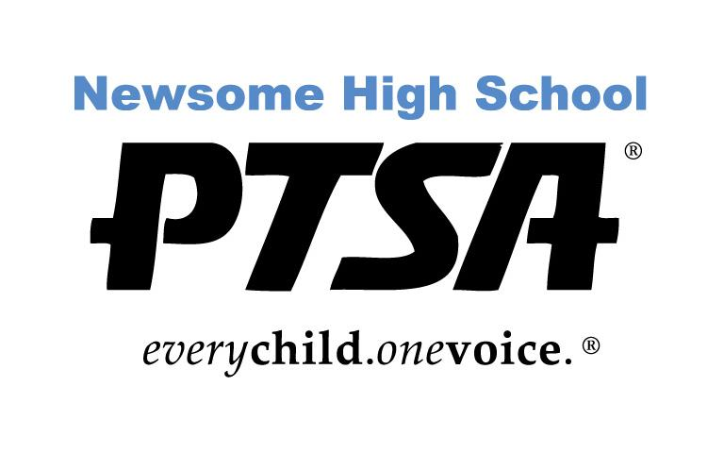
PTSA 2023-2024 Scholarship Application
Two-Year College—Community College, Technical or Trade School

The PTSA is pleased to offer scholarships up to $250 to outstanding seniors who are Newsome High School PTSA members by February 15, 2024. Scholarships are available to selected Newsome graduates pursuing a degree at various two-year institutions, including Community College, Vocational and Technical Schools. Scholarship winners will be announced at the Awards Night in April 2024.

A Scholarship Committee will base their decisions on several criteria: Newsome Activities and Leadership, Academics, Community Service/Work Activities, Essay, Activities outside of Newsome, and ONE Letter of Recommendation.

Newsome High School PTSA Scholarship requirements:

- Good Citizenship at Newsome as demonstrated by no OSS or ISS suspensions.
- Must be a 2024 graduating Newsome High School student in good standing
- Must be a student member of the PTSA
- Satisfactory scholastic record with a minimum GPA 2.0 (unweighted)
- Plan to attend an accredited community college, vocational or trade school full time (12 hours minimum).
- One Letter of Recommendation (No relatives)
- Essay (500 words or less)
- Activities and Achievement

You can only apply for one scholarship.

Application must be completed and turned in by 3:30 pm on THURSDAY, February 15, 2024 to the Guidance Office.

Don’t forget the senior student must be member of the Newsome PTSA by February 15th. You can purchase memberships at www.newsomehighschoolptsa.org

Please contact scholarships@newsomehighschoolptsa.org with any questions.

PTSA 2023-2024 Scholarship Application
Two-Year College—Community College, Technical or Trade School

Name:________________________________________________________________________________

Home Address:_________________________________________________________________________

Student Number: ____________________________________

ACADEMIC INFORMATION

Will you be eligible to graduate in the 2023-24 school year? Yes or No

SAT Score: Total: _____________

Evidence Based R/W: ___________ Math: ___________

ACT Score Composite: __________________

GPA (as shown on your transcript): Unweighted: __________ Weighted:___________

Name of Counselor: _________________________________________________________

Name of school(s) you have applied to?

Name of school(s) that have accepted or deferred you?

By submitting this application, I agree to have my Newsome High School Student Summary printed by the school and attached to this application for review by the judges. All names and addresses will be redacted in this application and student summary as judges only know your application by the number assigned to it.
PTSA 2023-2024 Scholarship Application
Two-Year College—Community College, Technical or Trade School

HIGH SCHOOL ACTIVITIES AND ACHIEVEMENTS:

Please list all Newsome High School organizations, activities, leadership positions, sports, or clubs in which you have participated. Please include the grade level of each activity or organization.

Briefly describe your activity and give other pertinent information (role in school play, musical instrument, team caption, varsity letter, special achievement). You may use more than one line per activity, or attach a typed list/resume of no more than two pages. RESUME IS PREFERRED.

COMMUNITY SERVICE and WORK EXPERIENCE:

Please list all community service activities and work experience in which you have been involved. Also include all activities outside of high school such as clubs, community sports or activities, and church activities. Indicate the grade level in which you were involved. Describe the activity or give pertinent information (including position). You may use more than one line per activity, or attach a typed list or resume of no more than two pages. RESUME IS PREFERRED.

ESSAY:
In 500 words or less, (typed and doubled spaced) based on your entire high school experience, which of the following activities have impacted you the most and why: Academics, Arts, Sports, School Clubs, or Community Service

Special Circumstances: Are there any special circumstances that affected your academics or involvement with extracurricular activities that you would like the Scholarship Selection Committee to be aware of?

Please explain.

________________________________________________________________________________________________________________________________________________________________________________________________________________________________________________________________________________________________________________________________________________________________________________________________________
__________________________________________________________________________________________

