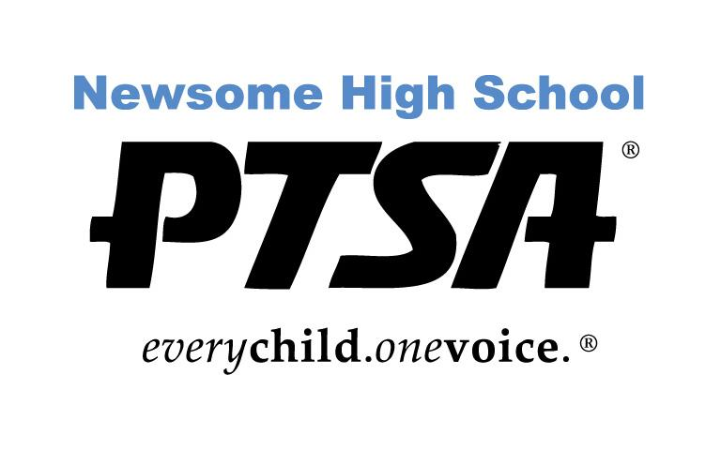
PTSA 2023-24 Scholarship Application
Four-Year College

The PTSA is pleased to offer scholarships up to $500 to outstanding seniors who are Newsome High School PTSA members by February 15, 2024. Scholarships are available to selected Newsome graduates pursuing a postsecondary education. Scholarship winners will be announced at Awards Night in April 2024.

A Scholarship Committee will base their decisions on several criteria: Newsome Activities and Leadership, Academics, Community Service/Work Activities, Essay, Activities outside of Newsome and ONE Letter of Recommendation. The Committee is looking for the well-rounded individual that represents Newsome.

Newsome High School PTSA Scholarship requirements:

- Good Citizenship at Newsome as demonstrated by no OSS or ISS suspensions
- Must be a 2024 graduating Newsome High School student in good standing
- Must be a student member of the PTSA
- Satisfactory scholastic record with a minimum GPA 3.0 (unweighted)
- Plan to attend an accredited university, or college full time (12 hours minimum).
- One Letter of Recommendation (No relatives)
- Essay (500 words or less)
- Activities and Achievements

You can only apply for one scholarship.

Application must be completed and turned in by 3:30 pm on THURSDAY, February 15, 2024 to the Guidance Office.

Don’t forget the senior student must be a member of the Newsome PTSA by February 15th! You can purchase memberships at www.newsomehighschoolptsa.org.

Please contact scholarships@newsomehighschoolptsa.org with any questions.

PTSA 2023-2024 Scholarship Application
Four-Year College

Name: ___________________________________________________________________________

Home Address: ____________________________________________________________________

Student Number: ___________________________

ACADEMIC INFORMATION

Will you be eligible to graduate in the 2023-2024 school year? Yes or No

SAT Scores: Total:______________

SAT Evidence Based R/W: _____________ Math: _____________

ACT Score Composite: __________________

GPA (as shown on your transcript): Unweighted: ______ Weighted: ______

Name of Counselor: _________________________________________________

Name of school(s) you have applied to:

Name of school(s) that have accepted or deferred you:

By submitting this application, I agree to have my Newsome High School student summary printed by the school and attached to this application for review by the judges. All names and addresses will be redacted in this application and student summary as judges only know your application by the number assigned to it.
PTSA 2023-2024 Scholarship Application
Four-Year College

HIGH SCHOOL ACTIVITIES AND ACHIEVEMENTS:

Please list all Newsome High School organizations, activities, leadership positions, sports, or clubs in which you have participated. Please include the grade level of each activity or organization.

Briefly describe your activity and give other pertinent information (role in school play, musical instrument, team captain, varsity letter, special achievement). You may use more than one line per activity, or attach a typed list/resume of no more than two pages. RESUME IS PREFERRED.

COMMUNITY SERVICE and WORK EXPERIENCE:

Please list all community service activities (include service hours) and work experience in which you have been involved. Also include all activities outside of high school such as clubs, community sports or activities, church activities. Indicate the grade level in which you were involved. Describe the activity or give pertinent information (including position). You may use more than one line per activity, or attach a typed list/resume of no more than two pages. RESUME IS PREFERRED.

The scholarship committee strongly recommends submitting a resume for high school activities/achievements and community service and work experience.

ESSAY:
In 500 words or less, (typed) based on your entire high school experience, which of the following activities have impacted you the most and why: Academics, Arts, Athletics, School Clubs, or Community Service

Special Circumstances: Are there any special circumstances that affected your academics or involvement with extracurricular activities that you would like the Scholarship Selection Committee to be aware of?

Please explain.

___________________________________________________________________________________________________________________________________________________________________________________________________________________________________________________________________________________________________________________________________________________________________________________________________________________________________________________________________________________________

