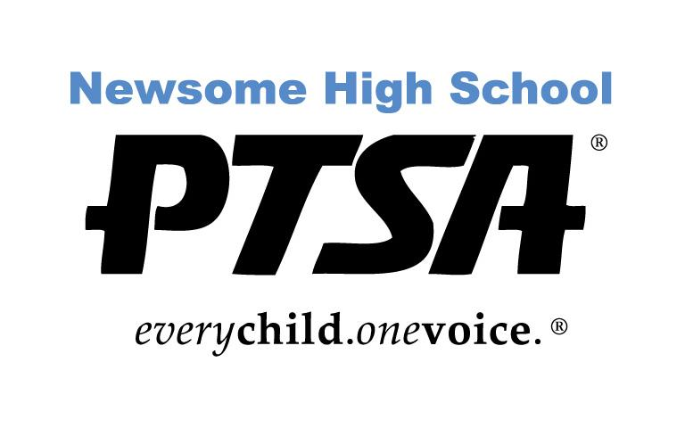
PTSA 2017-2018 Scholarship Application
Two-Year College

The PTSA is pleased to offer scholarships to outstanding seniors who are Newsome High School PTSA members by February 8, 2018. Scholarships are available to selected Newsome graduates pursuing a degree at various two-year institutions, including Community College, Vocational and Technical Schools. Scholarship winners will be announced at the Awards Night in April 2018.

A Scholarship Committee will base their decisions on several criteria: Essay, School Activities, Letters of Recommendations, GPA and Community Service/Work Activities.

Newsome High School PTSA Scholarship requirements:

- Good Citizenship at Newsome as demonstrated by no OSS or ISS suspensions.
- Must be a 2018 graduating Newsome High School student in good standing
- Must be a student member of the PTSA
- Satisfactory scholastic record with a minimum GPA 2.0 (unweighted)
- Plan to attend an accredited community college, vocational or trade school full time (12 hours minimum). Checks will be awarded upon proof of acceptance.
- Two Letters of Recommendation (No relatives and one must be a teacher)
- Essay (500 words or less)
- Activities and Achievement involvement form (see attached)

Application must be completed and returned by 2:45 pm on February 8, 2018 to Mrs. Linda Hacker, College and Career Counselor.

PTSA 2016-2017 Scholarship Application
Two-Year College

Name:______________________________________________________________

Student Number: ____________________________________

ACADEMIC INFORMATION

Will you be eligible to graduate in the 2017-2018 school year? Yes or No

SAT Score: Total: _____________

Evidence Based R/W: ___________ Math: ___________

ACT Score Composite: __________________

GPA (as shown on your transcript): Unweighted: __________

Weighted: __________

Name of Counselor:

_________________________________________________

Counselor verification (signature):_______________________________

Name of school(s) you have applied to?

Name of school(s) that have accepted or deferred you?

Don’t forget you must be a Newsome PTSA member by February 8, 2018!
ESSAY
In 500 words or less, (typed and doubled spaced) based on your entire high school experience, which of the following activities have impacted you the most and why: Academics, Arts, Sports, School Clubs, Community Service, or Work
PTSA 2016-17 Scholarship Application
Two-Year College

HIGH SCHOOL ACTIVITIES AND ACHIEVEMENT FORM

Please list all Newsome High School organizations, activities, leadership positions, sports, or clubs in which you have participated. Please include the grade level of each activity or organization.

Use the details section to briefly describe your activity or give other pertinent information (role in school play, musical instrument, team captain, varsity letter, special achievement). You may use more than one line per activity, or attach a typed list or resume.

COMMUNITY SERVICE and WORK EXPERIENCE FORM

Please list all community service activities and work experience in which you have been involved. Also include all activities outside of high school such as clubs, community sports, private lessons, church activities. Indicate the grade level in which you were involved. Use the details section to describe the activity or give pertinent information (including position). You may use more than one line per activity, or attach a typed list or resume.

Special Circumstances: Are there any special circumstances that affected your academics or involvement with extracurricular activities that you would like the Scholarship Selection Committee to be aware of?

Please explain.

______________________________________________________________________________________________________________________________________________________________________________________________________________________________________________________________________________________________________________________________________________________________________________________________________

Activities and Achievements
Gr. | Organization or Activity | Details

Community Service and Work Experience

Gr. | Organization/Activity/  Employer | Details

